Module Four: README File Creation Guide
Complete your README for the CRUD Python Module following this structure.

About the Project/Project Title
Austin Animal Center (AAC) CRUD Python Module
This project is a Python CRUD (Create, Read, Update, Delete) module that enables seamless database operations for the Austin Animal Center animal shelter database. The module serves as a bridge between client-side user interfaces and a MongoDB backend, allowing developers to interact with animal shelter data without writing MongoDB queries directly. The module implements an object-oriented approach through the AnimalShelter class, providing clean methods for inserting and querying animal records from the AAC shelter outcomes dataset.

Motivation
Animal shelters handle large volumes of data regarding animal intake, outcomes, and transfers. Managing this data efficiently is critical for operations, reporting, and decision-making. The primary motivation for this project is to create a reusable, well-documented Python module that abstracts away MongoDB complexity. By providing simple create() and read() methods, shelter staff and developers can focus on their applications rather than low-level database operations. This module promotes code reusability across multiple projects, particularly in the development of a dashboard application (Project Two) that requires both backend database connectivity and frontend user interface integration.

Getting Started
Database and Authentication Setup
This module connects to a MongoDB instance with the following configuration:
- Database: aac (Austin Animal Center)
- Collection: animals (contains 10,003+ animal records)
- User Account: aacuser with read/write privileges
- Authentication: MongoDB SCRAM-SHA-256 authentication on localhost:27017
The database was set up in Module Three by:
- Importing the aac_shelter_outcomes.csv file into MongoDB using mongoimport
- Creating single and compound indexes to optimize query performance
- Creating the aacuser account with read/write access to the aac database
Module Development Process
Creating the C (Create) Functionality: The create() method was developed to accept a dictionary of key/value pairs representing an animal record and insert it into the MongoDB collection. The method validates that data is not null before inserting and returns True on success or False on failure, allowing calling code to confirm successful operations.
Challenge encountered: Determining the appropriate error handling strategy. Solution: Implemented try/except blocks to catch MongoDB exceptions and return boolean values rather than raising exceptions, making the module more user-friendly.
Creating the R (Read) Functionality: The read() method was developed to accept a query dictionary and return all matching documents as a list. The critical requirement was to use find() with a cursor (not find_one()) to support returning multiple results.
Challenge encountered: Converting the MongoDB cursor object to a list format that calling code could iterate over. Solution: Used Python's list() function to convert the cursor to a list, which required understanding the cursor object's behavior and lazy evaluation.

Installation
Required Tools and Rationale
MongoDB 6.0+
- Rationale: Serves as the NoSQL database backend for storing animal shelter data. MongoDB was chosen for this project due to its document-oriented storage, which aligns well with unstructured animal data (varying attributes across different animals).
- Installation: Pre-installed in Codio environment; starts automatically on login
Python 3.x
- Rationale: Lightweight, readable programming language well-suited for database operations and data manipulation. Python's popularity in data science and backend development makes it ideal for this shelter management context.
- Installation: Pre-installed in Codio environment
PyMongo Driver
- Rationale: Official MongoDB driver for Python, providing direct access to MongoDB from Python code. PyMongo simplifies connection management and query execution.
- Installation: Usually pre-installed; if needed, run: pip install pymongo
Jupyter Notebook/Lab
- Rationale: Enables interactive testing and demonstration of CRUD functionality with live code execution and output display. Useful for prototyping and validating module behavior.
- Installation: Pre-installed in Codio; access via Codio toolbar
Setup Instructions
- Ensure MongoDB is running (auto-starts in Codio)
- Verify aacuser credentials are correct in AnimalShelter.__init__()
- Place CRUD_Python_Module.py in your project's code_files directory
- Import the module: from CRUD_Python_Module import AnimalShelter

Usage
Code Example
# Import and instantiate the module
from CRUD_Python_Module import AnimalShelter

shelter = AnimalShelter()

# CREATE: Insert a new animal record
new_animal = {
"name": "Buddy",
"age_upon_outcome_years": 3.5,
"animal_type": "Dog",
"breed": "Golden Retriever",
"outcome_type": "Adoption"
}

success = shelter.create(new_animal)
if success:
print("Animal record created successfully")

# READ: Query for all dogs adopted
query = {"animal_type": "Dog", "outcome_type": "Adoption"}
adopted_dogs = shelter.read(query)
print(f"Found {len(adopted_dogs)} dogs adopted")

# READ: Find all Pit Bulls transferred
pit_bull_transfers = shelter.read({"breed": "Pit Bull", "outcome_type": "Transfer"})
for dog in pit_bull_transfers:
print(f"{dog.get('name')}: {dog.get('outcome_type')}")
Tests
Testing was performed in Jupyter Notebook with the following scenarios:
Test 1: CREATE Single Document
new_dog = {"name": "TestDog", "breed": "Labrador Mix", "outcome_type": "Adoption"}
result = shelter.create(new_dog)
assert result == True # Verify successful insert
Test 2: CREATE Multiple Documents Inserted 2 additional animals and verified each returned True
Test 3: READ by Single Criterion
results = shelter.read({"breed": "Labrador Retriever"})
assert len(results) > 0 # Verify results returned
Test 4: READ by Multiple Criteria (Compound Query)
results = shelter.read({"breed": "Pit Bull", "outcome_type": "Transfer"})
# Verified compound index optimizes this query
Test 5: Verify Database Integrity
all_animals = shelter.read({})
assert len(all_animals) == 10003 # Original dataset plus 3 test records
Screenshots
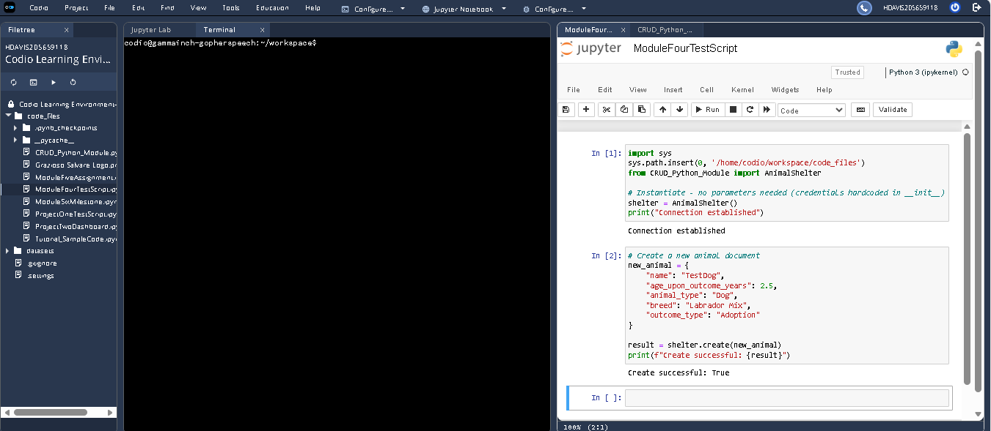
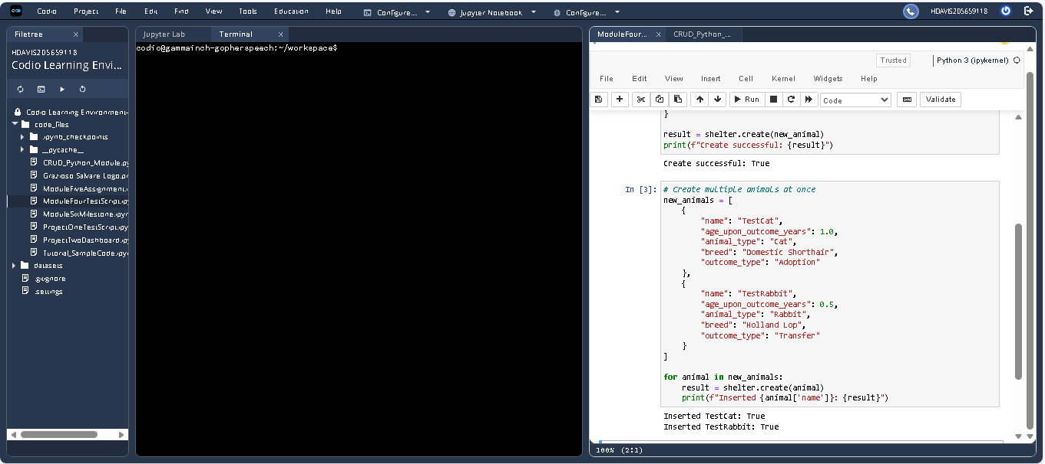
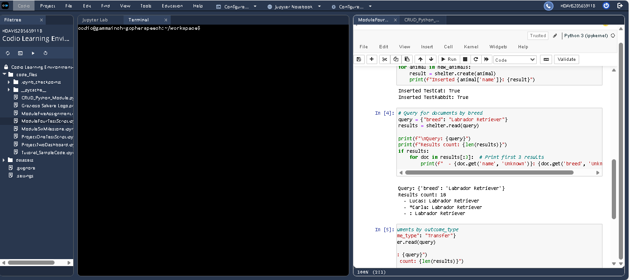
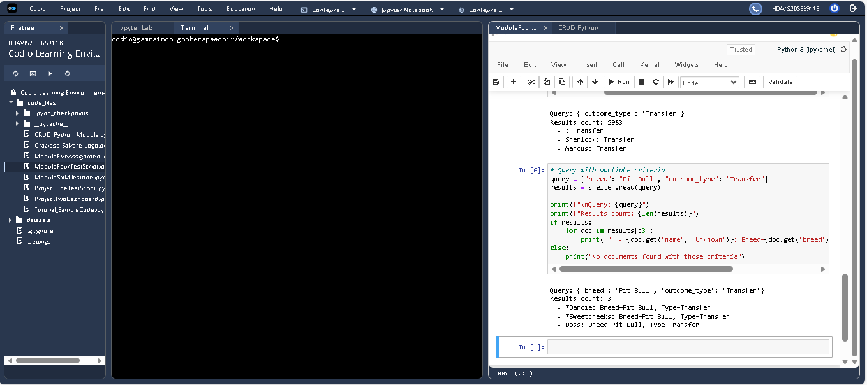
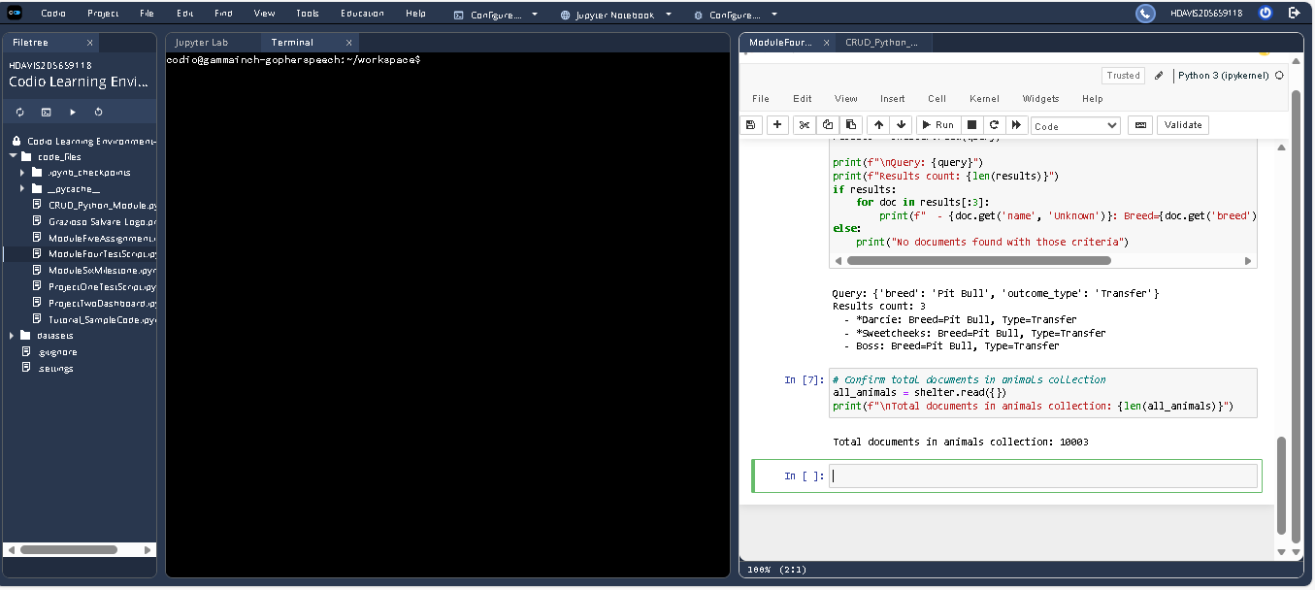

Contact
Name: Heath Davis
Institution: Southern New Hampshire University

